Extracted - https://www.realsimple.com/food-recipes/shopping-storing/food/how-to-store-watermelon

How to Store Watermelon So It Stays Juicy & Fresh
By Melissa Kravitz HoeffnerMay 18, 2022

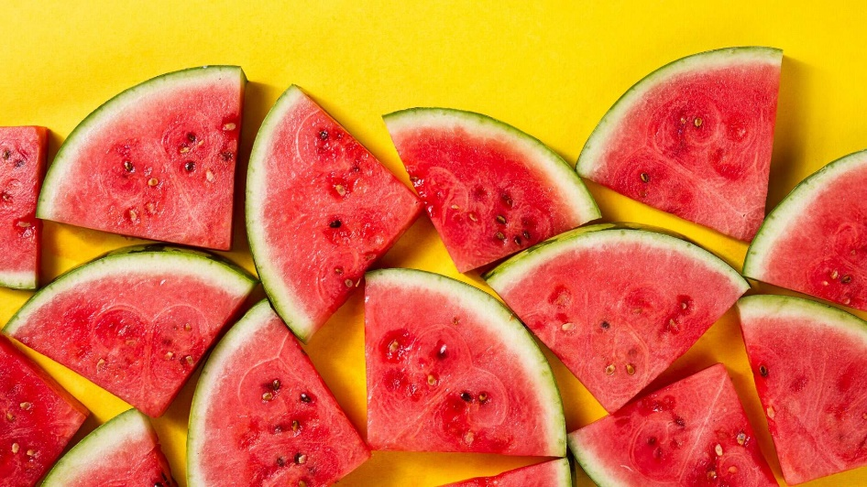

There's no pleasure like biting into a sweet, juicy summer watermelon. The fresh flavor, the texture, the beautiful color. It's perfection! But many of us watermelon lovers have sadly encountered the sad, starchy, less-than-flavorful slice—a major disappointment. This season, keep your watermelon fresh and delicious with our storage tips.

How to Buy Watermelon
The first step to preserving your watermelon's freshness: buying a nice watermelon. No matter what size or seed quantity you're going for, you want a watermelon with a firm exterior. If you can press your finger into it, it's no good. Try finding a watermelon free of dents and cuts, which can also lead to overrippening.
When you tap your watermelon, it should sound hollow, like a drum. That means there's delicious fruit and juice inside waiting to escape.

How to Store Watermelon
If you're not eating your watermelon right away, store it on the countertop, but out of direct sunlight. The USDA recommends leaving melons out at room temperature to maintain nutrients and flavor. In air conditioning or temperate weather, a fresh watermelon will be fine sitting on the counter for one to two weeks. According to the Watermelon Board, 55 degrees is the ideal temperature for a whole watermelon to be stored at.
If your watermelon is ripe and you don't have time to eat it, don't panic. But don't slice either. Slide that whole watermelon into the fridge, where it will stay fresh for two to three more weeks. The cool temperature of the refrigerator will slow the ripening process.

How to Store Cut Watermelon
Time to slice? Wash the outside of your watermelon thoroughly and use a sharp chef's knife or cleaver to slice off the bottom of the rind, leaving a flat surface for the rest of the carving. From here, you can make pie-shaped watermelon slices, cubes, or use a melon baller. If you prefer eating your melon cold, throw the fresh pieces into the fridge for an hour to chill. Make sure all the cut watermelon is tightly wrapped, in an air-tight food storage container or with plastic wrap (or an eco-friendly alternative) to preserve the texture and the juiciness.

How to Store Watermelon Juice
Watermelon juice is at its best when it's cold, so keep it in the fridge in a sealed container for up to four days. The liquid may separate a bit, so just shake it up before you drink it.

How to Store Watermelon Rind
Before you throw out the rind you separated from your watermelon flesh, consider pickling it! Pickled watermelon rind is a popular Southern condiment, and can be used in a variety of dishes or just eaten as a snack. The Watermelon Board's Rind Headquarters is also full of fun ideas for consumers who want to experiment with their rinds. For example, you can roast it, braise it, grind it into a gazpacho, shred it into a quiche, use it as a charcuterie accoutrement, and more. Meet your new favorite ingredient: Watermelon rind, because its applications are (almost) endless for sweet and savory dishes, plus, you already paid for it, so it's kind of a free bonus.

Can You Freeze Watermelon?
Yes, you can freeze watermelon, but definitely don't freeze the fruit whole. A whole watermelon in the freezer will get grimy, be impossible to slice into unless defrosted (and super-mushy at that point), and, depending on the actual juice content, may actually burst in your freezer!
That said, freezing watermelon can yield quite delicious results, and is a great way to prevent food waste. Frozen watermelon will stay fresh in the freezer for about a year. To freeze watermelon properly, follow the steps below:
- Cut the melon into small pieces. Balls or cubes work best, as they are easy to use in a variety of dishes.
- Remove the seeds.
- Spread the watermelon pieces on a baking sheet lined with parchment paper, making sure that they don't touch each other.
- Place the tray in the freezer for a few hours to flash-freeze the pieces. You will know they're frozen once they are firm.
- Move the watermelon chunks to a freezer-safe container or storage bag, label it with the date, and place it in the freezer.
You can use these still tasty watermelon pieces in cold summer drinks, like sparkling water, lemonade, or seasonal cocktails. If you are up for juicing your watermelon, freeze it in popsicle molds for a refreshing treat. Frozen watermelon can also be delicious in smoothies or tossed into blended cocktails.

