Raspberry Glazed Chicken

3 tbsp. olive oil | salt and pepper
½ cup diced red onion | 1/3 cup seedless raspberry preserves
1 tsp. dried thyme | 2 tbsp. balsamic vinegar
4 boneless, skinless chicken breasts

In large sauté pan, heat the olive oil. Saute the red onion over low heat until tender, about 5 to 7 minutes. Rub the dried thyme, salt and pepper onto the chicken breasts. Place chicken into pan and sauté for about 10 minutes on each side until golden and cooked through. Remove chicken from pan and keep warm. To the same pan, add the raspberry preserves and balsamic vinegar. Stir constantly until preserves melt. Spoon over chicken and serve.

Potato Latkes
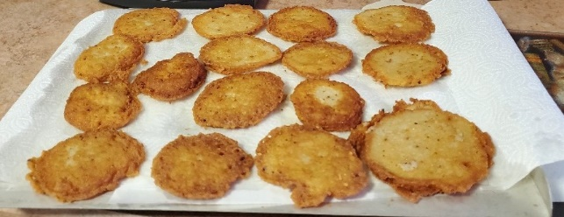
1 egg | 2 tbsp. All-Purpose Flour
1 tsp. Salt | 1/4 tsp. Baking Powder

3 cups Cubed Raw Potatoes

Assemble blender.
Put egg, salt, flour, baking powder and 1/2 cup of potato cubes into blender container.
Cover and process at GRATE until smooth.
Add remaining potatoes, cover and process 2 cycles at GRIND.
Pour onto a hot, well-greased griddle. Drain on absorbent paper.
Makes 12 latkes (pancakes).

Dipping Oil for Bread

1 tsp. Minced Garlic (i.e. - McCormick – California Style)
8 ozs. Regular Olive Oil | ½ tsp. Crushed Oregano
½ tsp. Crushed Basil | ½ tsp. Crushed Red Peppers

- Heat olive oil in sauce pan on stove and then put all ingredients in. Let olive oil absorb the flavoring. You can add more of any item (based on your taste).
- Then pour heated ingredients into the container.
- Then pass out the little plates and lots of delicious Italian bread and “Mangia”.
- The dipping oil gets even better after the first days (the ingredients really get into it). Just reheat and enjoy again and again and again.

Orange Meringue Rice Pudding

2 cups milk | 1/2 tsp. vanilla
1/3 cup long grain rice | dash of salt
2 beaten egg yolks | 2 egg whites
2 tbsp. orange marmalade | 3 tbsp. sugar
½ cup dark raisins (optional)

In a heavy saucepan combine milk and rice. Bring to boil; reduce heat. Cover and cook over low heat about 15 minutes or until rice is tender. Remove from heat.
Gradually stir about 1 cup of the hot rice mixture into beaten egg yolks. Return all to the saucepan. Stir in orange marmalade, vanilla and salt.
Pour rice mixture into a 8 x 6½ x 2-inch baking dish. Bake, uncovered, in a 350° oven for 12 minutes. Remove from oven. Stir rice mixture well.
At this point – if you want the raisins – add them and stir into rice mixture.
For meringue, beat egg whites until soft peaks form. Gradually add sugar, beating until stiff peaks form. Spread meringue evenly over the rice mixture, sealing to edges of baking dish. Swirl to make decorative peaks.
Return to 350° oven; bake for 8 to 10 minutes more or until meringue is golden brown.
Serve the pudding warm or cool in individual dessert dishes. Makes 6 servings.

Sweet & Creamy Pumpkin Dip

1 pkg (8 oz.) cream cheese - softened
2 cups confectioners sugar
1 Can (15 oz.) pumpkin
1 tbsp. McCormick Pumpkin Pie Spice

1 tsp. McCormick Orange Extract

½ tsp. McCormick ground Ginger

for Dipping – use Gingerbread Cookies or sliced apples or pears (tossed in lemon juice)

In a food processor, blend cream cheese and confectioners sugar until smooth.
Remove cover and add pumpkin and remaining ingredients. Blend thoroughly.
Chill 30 minutes or until ready to serve.
Serve with Gingerbread cookies or sliced fruit.

