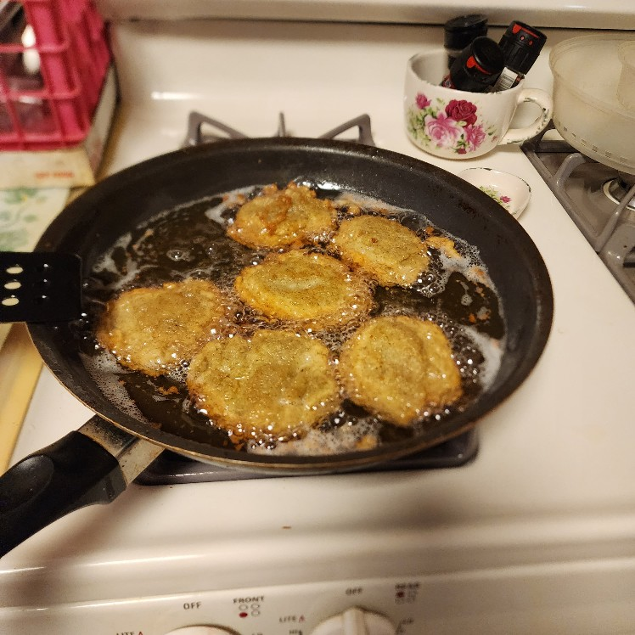 | 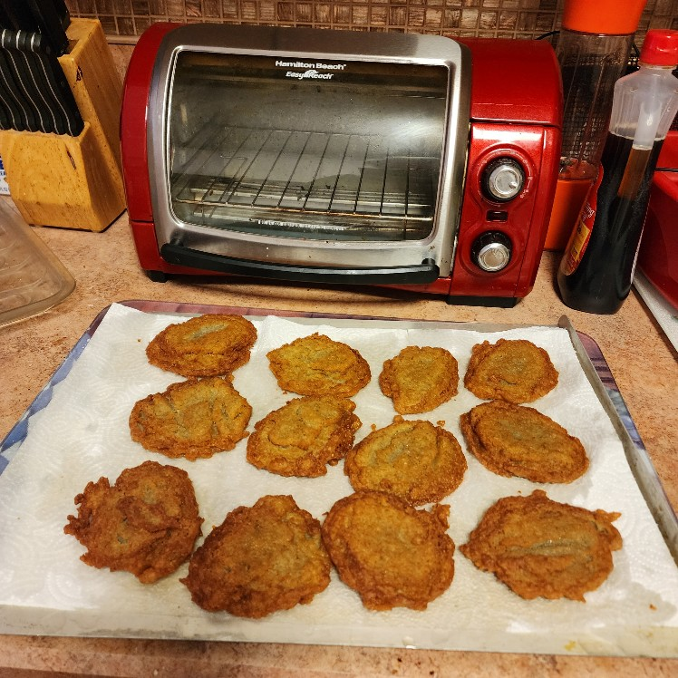
Ingredients:  - 1 egg  - 2 tbsp. All-Purpose Flour  - 1 tsp. Salt  - 1/4 tsp. Baking Powder  3 cups Cubed Raw Potatoes  Optional – Crushed Red Peppers | Assemble blender:  - Put egg, salt, flour, baking powder and 1/2 cup of potato cubes into blender container.  - Cover and process at GRATE until smooth.  - Add remaining potatoes, cover and process 2 cycles at GRIND.  - Pour onto a hot, well-greased griddle.  - Drain on absorbent paper.  - Makes 12 latkes (pancakes).

