Extracted from: https://wholefoodsoulfoodkitchen.com/chocolate-milkshake-without-ice-cream/

Chocolate Milkshake w/o Ice Cream
Can you make a creamy chocolate milkshake without ice cream? Absolutely! The recipe below is a healthier version of the classic chocolate milkshake you might know.
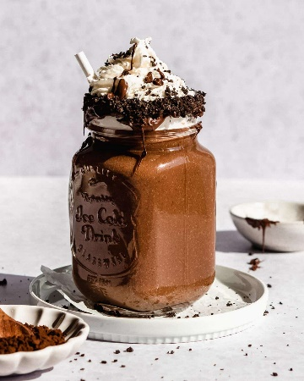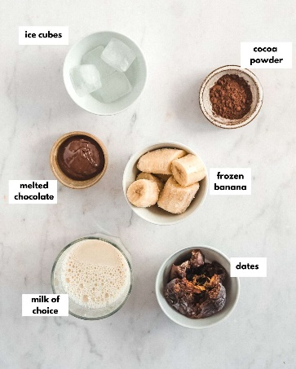
This delicious milkshake is perfect for everyone who tries to cut back on calories. It can be enjoyed all year round but tastes especially good during hot summer days!

Ingredients & substitution notes
- Frozen Banana: Instead of ice cream, we use a frozen banana. It helps to create a thick and creamy milkshake and also adds some natural sweetness. Don't worry if you're not a fan of bananas, the flavor isn't really noticeable.
- (Medjool) Dates: Dates are the perfect natural sweetener! They also add some fiber and nutrients as well. I highly recommend using Medjool dates because of their gooey texture and caramel-like taste! If you can't find any, regular dates will also work but you will need double to amount! If you don't want to include dates at all, you could use any other sweetener of choice such as maple syrup, honey or granulated sugar.
- Cocoa Powder: We used unsweetened cocoa powder in this recipe.
- Melted Chocolate of Choice (optional): For some ultimate chocolatey flavors, can be omitted but the milkshake will taste a bit different. Use vegan chocolate vor a vegan milkshake.
- Milk of Choice: You could use regular cow's milk or a non-dairy milk of choice such as oat milk, soy milk or almond milk. The higher the fat content of your milk, the creamier your milkshake will be! Make sure to use cold milk!
- Ice Cubes: To further thicken the milkshake.

How to make a chocolate milkshake without ice cream
This healthy chocolate milkshake recipe includes only 6 basic ingredients and is ready within 5 minutes.
For best results, you'll need a fairly strong blender. A regular blender won't be able to chop up the dates and create a perfectly smooth and creamy texture.

Step 1: blend
Add all of the ingredients to a high-speed blender and blend until smooth.
If you prefer a thicker texture, use less milk or add more ice cubes. For a runnier milkshake, gradually add more milk.
Step 2: assemble
Transfer the shake to a serving glass and add toppings of choice such as whipped cream or cocoa powder.

Extracted from: https://wholefoodsoulfoodkitchen.com/strawberry-milkshake-without-ice-cream/

Strawberry Milkshake w/o Ice Cream

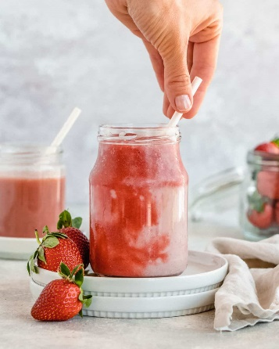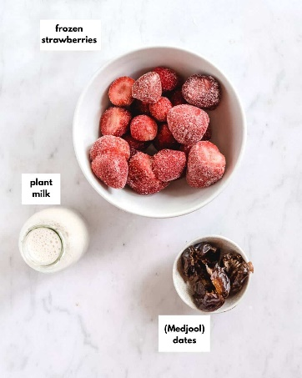
This homemade strawberry milkshake makes a delicious summer dessert and the perfect drink to try this strawberry season. It's a healthier milkshake recipe, made without ice cream, yet thick and creamy.
- 2 cups frozen strawberries
- 1½ - 2 cups soy milk (or any other milk)
- 3-5 Medjool dates *or regular, small ones

Instructions
- Put all of the ingredients to a (high speed) blender. Blend until smooth.
- Start with 1 ½ cups of milk and gradually add more milk if you prefer a thinner consistency. Or add more frozen strawberries for a thicker and creamier shake.
- Adjust sweetness by adding more dates or other sweetener of choice (maple syrup, honey,etc.)
Notes
- Dates: Feel free to replace them with any sweetener of choice such as regular white sugar, honey, maple syrup, agave syrup, stevia etc.
Tips:
- Cold Glass: Pop your serving glass in the freezer. Once its cold, the milkshake will stay cold and thick for longer. And make sure milk is very cold also.

