Extracted from - https://www.campbells.com/recipes/green-bean-casserole/

Green Bean Casserole

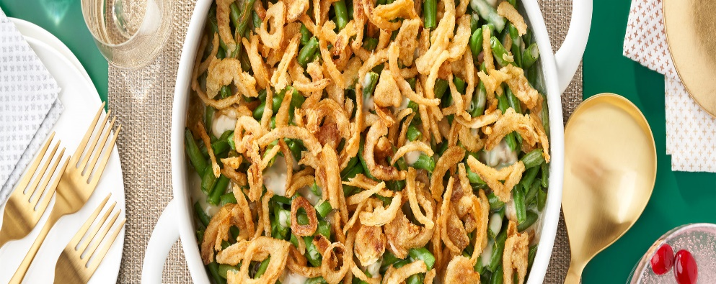
- prep time:10min
- total time:40min
- serves:6people
- calories:2311 serving
It is the dish everyone is expecting on the holidays, but it is so easy to make, you can serve it any day. Created by Campbell Test Kitchen Manager Dorcas Reilly in 1955, its creamy, smooth sauce and unmatchable flavor combined with its simplicity makes Green Bean Casserole so appealing. Just five ingredients and 10 minutes to put together, this family pleasing side has been a favorite for over 60 years. Looking to try a new spin on the traditional? Then try: Bacon & Cheddar Green Bean Casserole.

Ingredients
- 1 can (10 1/2 ounces) Campbell’s® Condensed Cream of Mushroom Soup or 98% Fat Free Cream of Mushroom Soup or Condensed Unsalted Cream of Mushroom Soup
- 1/2 cup milk
- 1 teaspoon soy sauce
- 4 cups cooked cut green beans
- 1 1/3 cups French's® French Fried Onions (amount divided in recipe steps below)
Get Ingredients Powered by Chicory

Instructions
- Step 1
Heat the oven to 350°F. Stir the soup, milk, soy sauce, beans and 2/3 cup onions in a 1 1/2-quart casserole. Season the mixture with salt and pepper.
- Step 2
Bake for 25 minutes or until hot. Stir the bean mixture. Sprinkle with the remaining 2/3 cup onions.
- Step 3
Bake for another 5 minutes or until the onions are golden brown.

