Extracted from - https://30seconds.com/food/tip/46454/Grandmas-Easy-Pineapple-Bread-Recipe-Is-Unbelievably-Moist#amp_tf=From%20%251%24s&aoh=16569619259983&csi=0&referrer=https%3A%2F%2Fwww.google.com&ampshare=https%3A%2F%2F30seconds.com%2Ffood%2Ftip%2F46454%2FGrandmas-Easy-Pineapple-Bread-Recipe-Is-Unbelievably-Moist

Grandma's Easy Pineapple Bread Recipe Is Unbelievably Moist
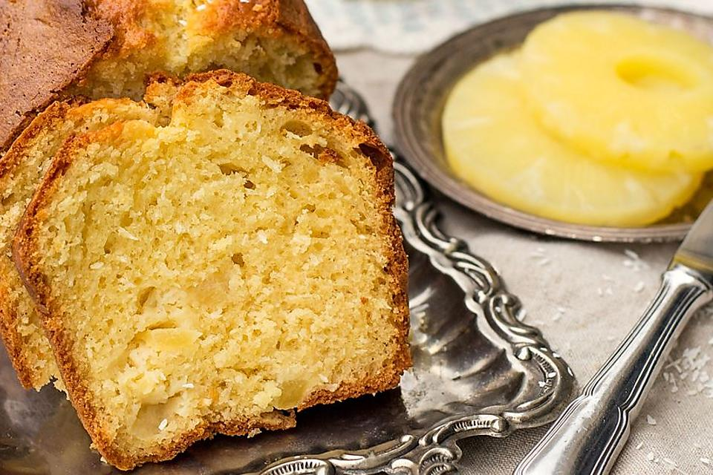
Who doesn't remember their grandma pulling a warm loaf of sweet bread out of the oven? From date bread to banana bread to gingerbread to lemon poppy seed to chocolate, sweet dessert bread comes in all varieties.
This easy pineapple bread recipe gets its moistness from crushed pineapple. The bread is so moist that it doesn't need a glaze. Serve with a cup of coffee or tea for dessert or a snack.
Cuisine: American
Prep Time: 10 minutes
Cook Time: 1 hour
Total Time: 1 hour and 10 minutes
Servings: Makes 1 loaf
Ingredients
- 1/2 cup (8 tablespoons) butter, melted
- 1 cup granulated sugar
- 2 eggs
- 2 cups flour
- 1 teaspoon baking powder
- 1/2 teaspoon baking soda
- 1/4 teaspoon salt
- 1 can (8 ounces) crushed pineapple, drained
- 1 teaspoon vanilla
Here's how to make it:
- Beat together the butter and sugar with an electric mixer. Add the eggs and vanilla and beat until well combined. Stir in the pineapple.
- In a bowl, whisk together the flour, baking powder, baking soda and salt. Add the dry ingredients to the wet ingredients until just combined.
- Pour the batter into a 9x5-inch loaf pan that's been sprayed with nonstick cooking spray. Bake in a preheated 350-degree F oven for about 1 hour or until a toothpick comes out clean. Cool about 10 minutes before removing from the pan to cool completely.

