Extracted from - https://thishealthykitchen.com/air-fryer-pineapple/

Air Fryer Pineapple (Tastes like Grilled)
Sweet, caramel-ly air fryer pineapple! An absolutely perfect healthier dessert or side dish that you’ll want to devour. Simple to make, with just 4 ingredients required and ready in under 20 minutes.

Serve this delicious treat on the side of your main course, or use it as a healthier dessert option. It’s so satisfying, either way! It’s similar to grilled pineapple, but no need to fire up the grill!
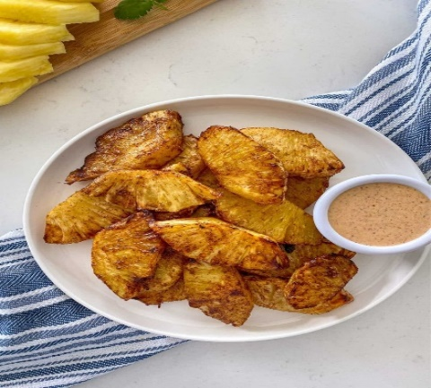00: 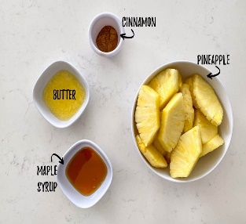

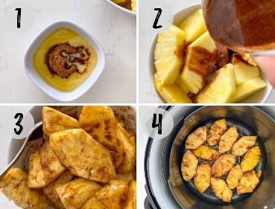

INSTRUCTIONS
(This is a summary with step by step photos, full recipe measurements and instructions
Peel, core and slice your pineapple. Place in a mixing bowl and set aside.
Then combine the butter, maple syrup and cinnamon in a small bowl and pour it over the pineapple slices. (photos 1-2)
Gently mix to evenly coat the slices and arrange them in a single layer in your fryer basket. (photos 3-4)

RECIPE
Prep Time: 8 minutes
Cook Time: 12 minutes (start at 10 since each air fryer cooks differently)
Total Time: 20 minutes
Servings: 4 Servings

Equipment
- Air Fryer

Ingredients
- 2 heaping cups sliced pineapple from approx. ½ small pineapple
- 1 tablespoon vegan butter or margarine melted, optional
- 2 tablespoons maple syrup
- 1 teaspoon cinnamon

Optional Chili Lime Dip
- 3 tablespoons cashew cream or vegan mayo
- 1 tablespoon lime juice approx. half a lime
- ½ teaspoon chili powder

Instructions
- Peel, core and slice your pineapple and place about 2 heaping cups worth in a mixing bowl.
- Combine the melted butter, maple syrup and cinnamon in a small bowl, then pour it over your pineapple slices. Mix gently to even coat the slices.
- Then place them in a single layer (slightly overlapping is fine) in your fryer basket and air fry at 380 degrees F for (check at 10 minutes due to different air fryers) 12-15 minutes, or until caramelized. Flip the pineapple once at the halfway point.
- Enjoy warm or cold, as a side dish or dessert.

Optional Dip
- If making the chili lime dip, combine the 3 ingredients in a small bowl while your pineapple is cooking.

Notes
Don’t dump the pineapple slices into your fryer basket. Instead, spoon them in one at a time to avoid breaking them, and prevent excess liquid from dripping down below your basket and smoking.

STORAGE
In the unlikely event there are leftovers, store them in the fridge for 2-3 days in a sealed container.
You may reheat for 1-2 minutes in your fryer or toaster oven but watch carefully.

