Extracted from - https://knifeandpaddle.com/air-fryer-philly-cheesesteak-egg-rolls/
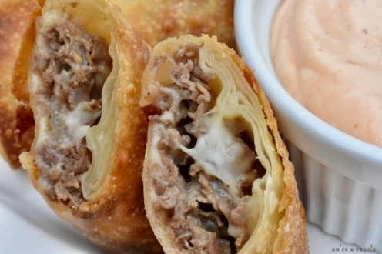

Air Fryer Philly Cheesesteak Egg Rolls
All the great flavors of a Philly Cheesesteak wrapped in a neat, little package. These Air Fryer Philly Cheesesteak Egg Rolls are perfect as an appetizer or part of a game day spread.

Living near Boston, the ability to get a good Philly Cheesesteak is challenging, to say the least. When football season comes around, I find myself craving those flavors. These Air Fryer Philly Cheesesteak Egg Rolls hit all the classic flavors. If you are planning a get together for game day or need an appetizer for a party, make them ahead of time. Just do the frying before serving.
PREP TIME: 25 mins // COOK TIME: 10 mins
TOTAL TIME: 45 mins // SERVINGS: 12 Egg Rolls

EQUIPMENT
- Air Fryer
- Fry pan

INGREDIENTS

16 oz shaved beef Rib Eye Preferred
- 1-2 tbsp oil
- 8 oz provolone cheese shredded
- 1 med onion chopped
- 1 tsp salt
- 1 tsp garlic powder
- 1/2 tsp pepper
- 12 each egg roll wrappers

Sriracha Dipping Sauce
- 1 cup mayonnaise
- 1 tbsp sriracha hot chili sauce plus more until desired heat level is reached

INSTRUCTIONS
- Chop the onion. Add oil and sauté on medium low heat until translucent.
- Roughly chop beef and add to the sauté pan.
- Add salt, pepper and garlic powder. Cook meat all the way through.
- Remove meat mixture from heat and place in a bowl. Let cool.
- Shred the cheese. Add half of the cheese to the meat mixture and incorporate.
- Place an egg roll wrapper on a cutting board so that it looks like a diamond. Add 2 Tbsp of the meat mixture and sprinkle a little more cheese on top.
- Roll the bottom corner up to cover the meat. Fold in the sides. Wet the top corner with a little water and roll it down.
- Place on a tray and repeat until all the meat/cheese mixture is used up. About 12 egg rolls.
- Preheat the air fryer to 390 degrees.
- Spray the egg rolls with olive oil. Place them in the air fryer, taking care not to crowd.
- Cook for 10 minutes, turning half way through. All air fryers cook differently, so you may need to adjust the cooking time based on your machine and cook preference.
- Remove the egg rolls from the air fryer tray.
- Serve with the sriracha dipping sauce.
- Enjoy!

Sriracha Dipping Sauce
- In a small bowl add mayonnaise and sriracha sauce. Mix together.
- Add more sriracha sauce until desired heat level is reached.

Cheesesteak Egg Rolls-Ingredients
Egg roll wrappers, beef steak, provolone cheese, onion. Don’t forget that olive oil baking spray!
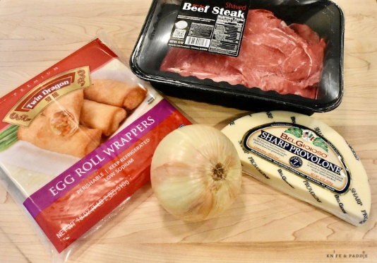

Cheesesteak Egg Rolls-Instructions
For the filling. Chop the onion. Add oil to the pan and sauté on medium low heat until translucent. Roughly chop the beef and add to the sauté pan. Add salt, pepper and garlic powder. Continue until meat is cooked through. Remove from heat, place in a bowl and let cool.
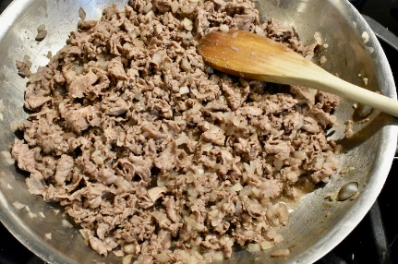
Shred the provolone cheese. Add half of the shredded cheese to the meat mixture and incorporate.
Place an egg roll wrapper on a cutting board, so that it looks like a diamond. Add 2 tbsp of the meat mixture and sprinkle a little more cheese on top.
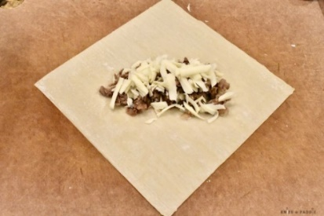
Roll the bottom corner up to cover the meat.
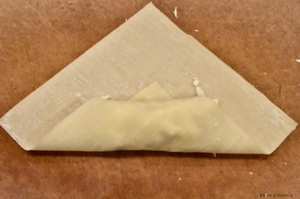
Fold in the sides.
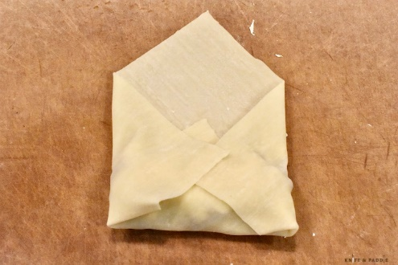
Wet the top corner with a little water and roll it down.
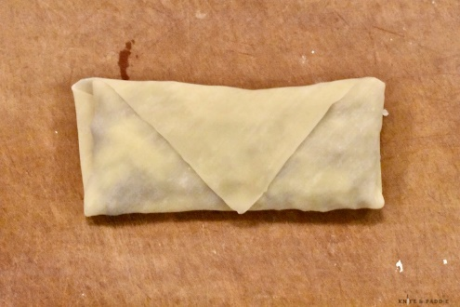
Place on a tray and repeat until all the meat / cheese mixture is used up. About 12 egg rolls.
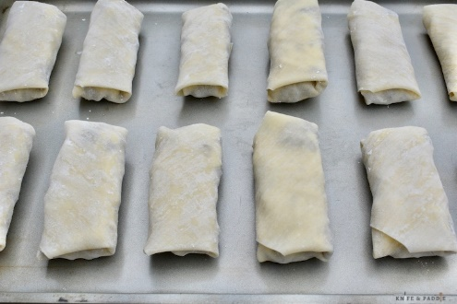
Preheat the air fryer to 390 degrees. Spray the egg rolls with olive oil. Place them in the air fryer, taking care not to crowd
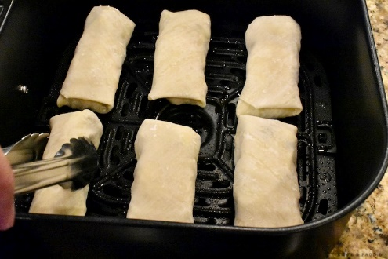
Cook for 10 minutes, turning half way through. All air fryers cook differently, so you may need to adjust the cooking time based on your machine and cook preference. Remove the egg rolls from air fryer tray
Serve with the sriracha dipping sauce. Enjoy!

