Extracted from:
https://therecipecritic.com/air-fryer-whole-chicken/

Bottom of Form

Air Fryer Whole Chicken
Alyssa Rivers
Air Fryer Whole Chicken is going to change the way you do chicken! Super easy, it comes out perfectly tender, juicy and full of flavor!
PREP TIME: 5minutes
COOK TIME: 1hour
TOTAL TIME: 1hour -- 5minutes
COURSE: Dinner, Main Course
CUISINE: American
SERVINGS: 8 People
CALORIES: 327 kcal

INGREDIENTS
- 1 (4-5) pound whole chicken giblets removed
- 2 Tablespoons olive oil
- 1 Tablespoon Italian seasoning
- 1 teaspoon garlic powder
- 1/2 teaspoon paprika
- salt and pepper

INSTRUCTIONS
- Rub the chicken with the oil. In a small bowl combine italian seasoning, garlic powder, paprika and salt and pepper. Rub all over the chicken.
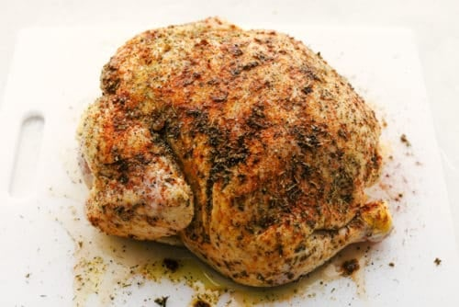
- Place the chicken breast side down in the air fryer. Cook at 360 degrees for 30 minutes.
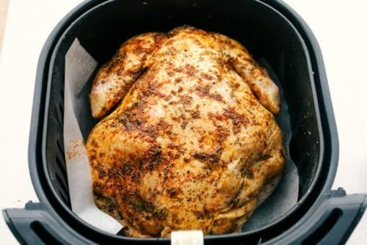
- Flip the chicken and cook for an additional 30 minutes or until the chicken reaches an internal temperature of 165 degrees.
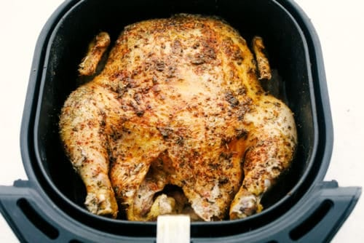

NUTRITION
Calories:
327kcal // Carbohydrates: 1g // Protein: 25g // Fat: 24g
Saturated Fat: 6gTrans

Fat: 1g Cholesterol: 102mg // Sodium: 96mg
Potassium: 272mg // Fiber: 1g // Sugar: 1g
Vitamin A: 263IU // Vitamin C: 2mg // Calcium: 26mg // Iron: 2mg

