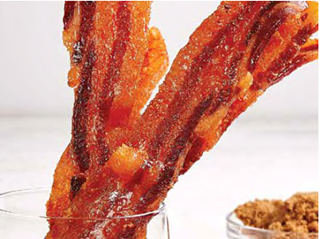
CANDIED BACON – Serves 4
Ingredients:
1 lb. thick bacon
¹/₄ cup dark brown sugar
¹/₄ tsp. cayenne pepper
2 tbsp. maple syrup

Directions:
- Lay the bacon strips onto the Air Flow Racks and trim as needed.
- Sprinkle the brown sugar and cayenne pepper over the bacon and rub into the meat.
- Brush the bacon with the maple syrup.
    - I find it easier to put brown sugar & maple syrup in container – and put in microwave for about 15 seconds – easier to spread.
- Place the Racks in the Power AirFryer Pro. Press the Power Button and then the Shrimp Button (320° F/160° C for 12 mins.) to begin the cooking cycle.
- When the cooking cycle is complete, flip the bacon.
- Press the Power Button and then the Shrimp Button (320° F/160° C for 12 mins.) to begin the cooking cycle again.
- Serve on a Charcuturie board.

