Arlene’s Last Word.doc
I really struggled with how to present the October 2001 Sales Newsletter. Do I do my fun graphics and music for Halloween or do I make it solemn due to what MY country has gone through. I decided to do it the way it was created and designed to be - fun & upbeat.
I have seen battles and wars all my life (and even created a few myself). I was born during World War II; was a youngster during the Korean War; a teenager during the Vietnam War, etc. I have witnessed battles such as the "Bulge" (trust me, as you get older - that really can be a losing one); wars against segregation, bigotry, AIDS, spinal cord injuries, MS, MO, Parkinson, Alzheimer, Cancers (yes, I smoked 3 packs of cigarettes a day for 30 years and quit almost 14 years ago - hopefully soon enough) and have watched MY country move forward against these and many others and in many cases winning them. The most recent being "Stem Cell Research". Can you imagine what that will mean to millions of people?
I am very possessive when it affects MY country and all of MY people. September 11, 2001 at 8:45am (DST) nearly destroyed me. I call it "The Day of the Monsters". These "people" are neither human nor animal nor aliens. They are creatures known as "Terrorists" who violated MY country and injured, maimed and killed MY people and destroyed MY beautiful buildings. I know of no one that was directly affected but that doesn't matter. I cried and wept with everyone that was hurting since they are all America's family. How DARE these creatures come into MY country, take MY planes with MY people on them and without any regard for human life smash them into symbols of America and kill thousands of people. I feel totally violated and will NEVER forgive them what they did. At the same time, it is so very important that we do not start blaming, hurting, maiming or killing people; otherwise we are then no better than the MONSTERS. I have many friends that are from all over the world that live in the United States of America. I have extended my hand to them in every way possible to let them know that most people in this country are good decent people. However, it is important that our government gets these MONSTERS and destroys them; yes, I am vindictive.
With Rosh Hashannah (the Jewish New Year) having started on September 18, 2001 - it is now the year 5762. I hope and pray that we all continue to support our government and pray and remember what happened on September 11th. MONSTERS and CREATURES (a/k/a Terrorists) are not allowed to destroy MY American way of life or for that matter any other part of this good home we call Earth. It is important to remember that whether you are Jewish, Christian, Muslim or one of a multitude of other faiths and religions practiced in America; whether you black, white, brown, yellow or somewhere in between that we are ALL Americans living in the most wonderful country in the world.
As I get ready to celebrate the start of my 36th year with Xerox and my 58th year on this good earth; I wish everyone the best and hope that someday the hurt will go away and that our Earth will be rid of those that attempt to violate it.

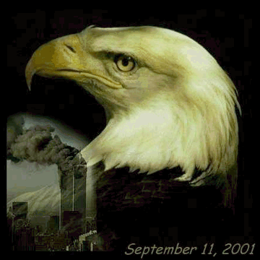 | 

