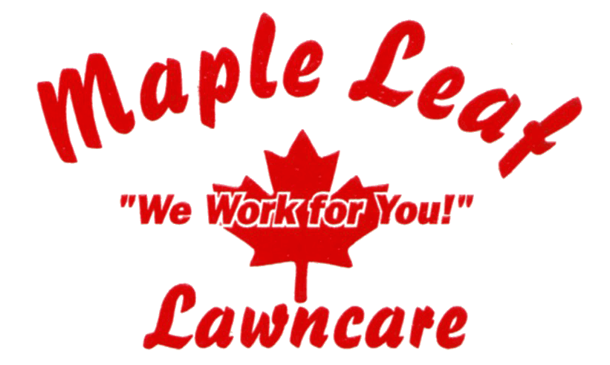 |  |  |  |  |  | Contact: Ed Van Hee or Jim Daley  Office Phone #: 856-665-5020  Ed's Cell #: 856-220-5914  Fax #: 856-374-3016  Email: info@MapleLeafLawncareInc.com
“Maple Leaf Lawncare Inc” has been in business since 1987 (over 25 years)
providing professional and courteous service in the landscaping industry.
Below are some of the services our company offers:
 | Landscaping |  |  |  | Yard Renovation including Tree and  Stump Removal
 | Turf / Lawn Mowing as well as Maintenance |  |  |  | Planting and Maintaining of Trees and  Shrubs
 | Spring and Fall Clean-Ups |  |  |  | Snow Removal
 | Mulching |  |  |  | Ice Removal
"We Work for You"
both residential (including apartment complexes, condos, HOA's, etc.) as well commercial customers.
We are located in Pennsauken (Camden County) and service the following counties in New Jersey:
Atlantic, Burlington, Camden and Gloucester as well as Philadelphia Area.
© Copyright-2012 - MapleLeafLawncareInc.com  All rights reserved. |  |  |  |  |  |  | Webmaster: Arlene E. Litvin  Website: www.pinklady101.com

