 | 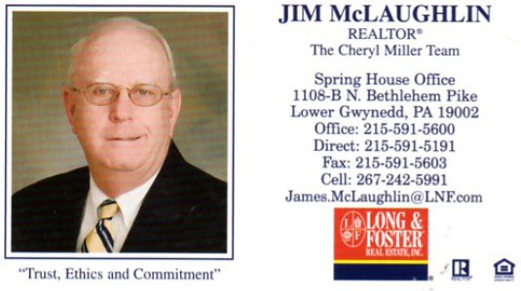
Property Information:
Address:
City & State:
Thank you so much for joining us today at our Brokers Open House.
How did the home show?
What were the strengths of the home?
Were there any drawbacks to the home or location?
What is your opinion of the price of the home?
What suggestions would you like to share with the owner with regards to staging, general maintenance, price or any other item of note?
Thanks, Jim
Realtor’s Name who gave input:
Realtor’s Agency Name:
Your Phone # (s):

